Exhibitor profile

JANE JAMES AND ASSOCIATES
Exhibition stand:
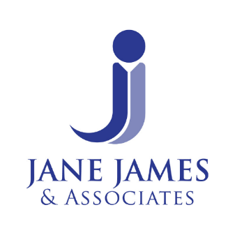
Jane James and Associates are an award nominated, family run, expert witness reporting company. With over 35 years of experience, we provide straightforward, highly regarded clinical negligence and personal injury reports supported by a first-rate, personalised and professional service you can rely on. We work with both Claimant and Defendant legal representatives.
Going the extra mile for our clients: When you engage our services, you benefit from a motivated and well-supported team of experts who are genuinely invested in providing the best possible, high-quality reports for the Court. In addition, our dedicated internal expert liaison team is always on hand to provide pragmatic, professional advice and ensure your instructions run smoothly.
Our Reports: Our liability reports are well presented, clear and concise, and our experts are trained to understand the terminology and phraseology relating to the legal tests used in liability reporting. Our quantum reports are equally well-presented, robust, straightforward to read, and transparent on costs. Our experts are trained to understand that the objective is to quantify the Claimant's past, ongoing and future needs and that their recommendations must be reasonable and justifiable.
Our Experts: Our experts are highly experienced registered nurses, occupational therapists, and physiotherapists. Many of whom work as case managers within litigation. JJ&A experts receive comprehensive expert witness training and understand and adhere to the Civil Procedure Rules.
We would be delighted to discuss our teams’ services with you. Contact us on 01249 456360 or info@jjaltd.co.uk or visit www.janejamesandassociates.co.uk to find out more.
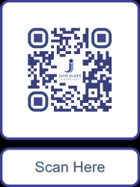
C/O Pond House
Church Lane
East Kennett
Wiltshire
SN8 4EY
T: 01249 456360
E: info@jjaltd.co.uk
W: www.janejamesandassociates.co.uk

