Michael Green
Scottish Government
St. Andrew's House
Regent Road
Edinburgh
EH1 3DG

By email only: courtfeeconsultation@gov.scot

Dear Sirs
Scottish Court Fees 2022-2025 - A consultation
APIL welcomes the opportunity to provide comments to the Scottish Government in relation to proposals to increase court fees. APIL disagrees with the suggestion at paragraph 9 of the consultation that court users should meet the full costs of the system. This is a flawed approach – the court service is for the benefit of the whole of society and should be funded, in the main, through taxation.
We also maintain that the level of service within the court system should be reflective of the fees paid. We have already made arguments to the Scottish Government about the importance of a return to face-to-face proof hearings – these can be found here: https://www.apil.org.uk/files/pdf/ConsultationDocuments/4022.pdf . Pursuers and their representatives have reported, throughout the pandemic, the difficulties in accessing justice when hearings have been based remotely. Pursuers have not been able to accurately put their case across and have not felt heard. On numerous occasions the internet has failed and people have been disconnected from hearings, for the hearing to simply proceed without them. Justice should not be based on who has the strongest WiFi signal, and court users should not be faced with increased fees when the level of service has been reduced.
While the proposed increases are in line with inflation, continuous year on year increases will be a potential barrier to access to justice. This is particularly the case if solicitors’ fees remain static, as most court fees are paid by the pursuer’s solicitor upfront. If court fees are to keep pace with inflation, so too should the expenses paid to solicitors.
Group proceedings
We believe it is too early to make observations on court fees and exemptions for group proceedings.
We hope that our comments prove useful. If you would like to discuss anything in our response further, please contact Alice Taylor, alice.taylor@apil.org.uk in the first instance.

Yours faithfully
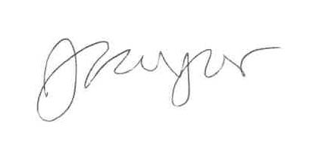
Alice Taylor
Legal Policy Manager
APIL

